Problem:

In geometry, a star is a five-sided polygon. Each internal angle is 36 degrees.

implement a python program that draws the below diagram using the turtle.

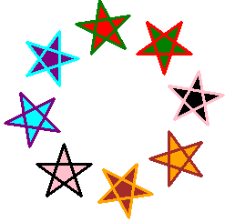

You should consider the following points in your solution:

1. Each side has a length of 60 units.
2. Stars have at least 4 different border colors.
3. Stars are all filled with the shown color.
4. The border lines should be thick enough.
5. The final shape of the output should be as shown above.
6. You might place the desired colors in a list to access them by index in the drawing loop.
7. Make sure to set properly the starting position (x & y) of your drawing, to maintain the above diagram.

Hint: You can use the below colors and fills

**colors= ['red', 'pink', 'brown', 'orange’, ‘black', 'purple', 'cyan', 'green']**

**fill= ['green', 'black', 'orange', 'brown', 'pink', 'cyan', 'purple', 'red']**